Consumer Advisory Body Report 2025
September 2025

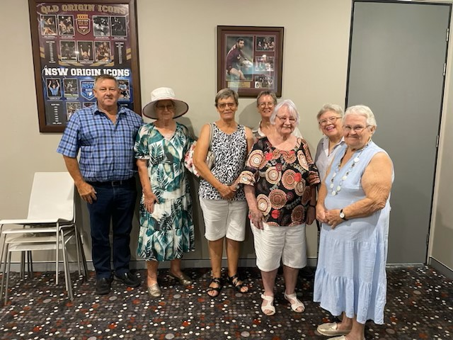

Longreach Home and Community Care Inc

Report to Management Committee
Subject:
Endorsement of reform initiatives and recommendations to enhance social
connectedness for elderly in our community.

Prepared by: Consumer Advisory Body

The Consumer Advisory Body welcomes this opportunity to provide feedback and strategic
recommendations in support of Longreach Home and Community Care’s ongoing efforts to
provide quality person-centred care to the elderly in our community.

We commend the Committee, as volunteers, for their commitment and oversight of
high-quality care services delivered to our elderly residents, particularly in the context of
our rural setting where geography and equity remain critical challenges.

Our advisory body has identified an issue of concern among some of our elderly: social
isolation due to geographic distance and limited mobility. There are older people living in
our community separated from family and friends, leading to loneliness, a sense
of disconnect, and diminished capacity for community engagement; resulting in reduced
physical and emotional wellbeing.

We recommend the inclusion of digital technology solutions to address this issue, such as:
- Using CHSP capped grant funding of $500 pp to purchase IT equipment
(laptop, tablet or ipad) to help connect older people to their family or friends.
- Promoting the use of this capped funding to ‘at risk’ recipients who have been
assessed as needing individual social support or group social support and have
referral codes
- Training staff to support video calling during rostered social support visits
- Providing digital literacy workshops for older adults

These initiatives would not only support social connectedness but also align with providing
quality care services that are individualized and meet community needs.

The Consumer Advisory Body are committed to working collaboratively with the management
committee on continuous improvements which consider our lived experiences.

We ask the management committee to endorse the exploration and integration of digital
technology to enhance social connections for those at risk of social isolation.

[DATE]

Agenda


Acknowledgement of Traditional Custodians.

Acknowledgement of Collective Wisdom.

R E - C A P F R O M L A S T M E E T I N G

Re-cap of actions from our last meeting

M A N A G E M E N T F E E D B A C K T O T H E G R O U P

Summary and comments from our management to you
- Open discussion

T H I S M O N T H ' S T O P I C S F O R D I S C U S S I O N

We will share some of the updates from the Dept of Health & Aged Care, and the Quality & Safety Commission.
Explore your thoughts on the topics, and how they relate to the care and services you receive from us.

A N Y T H I N G Y O U ' D L I K E T O S H A R E O R A S K ?

Open forum for issues you'd like us to consider for next meeting.

N E X T M E E T I N G -
[insert date]

Notes

[insert date]

